

Southern California Edison
CS Re-Platform Project

CIM-CS-05-Handle Request-Process Field Work Request
Customer Interaction Management
Business Process Design
Version 1.9

Table of Contents
1 Business Process Overview 5
1.3 Current Pain Points for Southern California Edison 5
1.2 Responsible Parties 5
1.3 Document Control 6
1.4 Terminology 6
2 Business Process Design 8
2.1 Manage Field Work Request Details 8
2.1.2 Work Order Creation for SCE Customers 10
2.1.3 Work Order Creation for non-SCE Customers 10
2.1.4 Work Order Completion 12
2.2 Process / Performance Improvement 12
2.3 Prerequisites and Inputs 12
2.4 General Assumptions 13
2.5 Business Process Hierarchy 13
2.6 Process Flows 13
2.6.1 Work Order Processing 14
2.7 3rd Party and SCE Legacy System Integrations 16
2.8 Data Elements 16
2.8.1 Service Order Data Elements 16
Please refer to the BPD DF-WM-02 - Handle Field Orders - Manage Field Orders for detail data elements. 16
2.8.2 Source Systems and Data Volumes 16
2.9 Cloud for Customer (C4C) Integration 16
2.9.1 Processes 16
2.9.2 C4C Views 16
2.9.3 Activity 16
2.10 Exception Management Requirements 17
2.11 Process Risks and Mitigation 17
2.12 Key Performance Indicators 17
2.12.1 Key Metric Definition 17
3 Controls, Regulatory Rules, and Security 18
3.1 Security Considerations 19
3.2 Custom Program/Transaction Codes 20
3.3 Custom Table/Transaction Codes 20
3.4 Data Criticality and Cybersecurity Baseline Risks 20
4 Technical Considerations 22
4.1 RICEF-W Assessment 22
4.1.1 Reports 22
4.1.2 Interfaces 22
4.1.3 Conversion 22
4.1.4 Extension/Enhancements 22
4.1.5 Forms 22
4.1.6 Workflows 23
4.2 IDEX Considerations 23
4.3 Production System Cut-over Considerations 23
4.4 Other Considerations 23
5 Change Management 24
5.1 Change Impacts 24
6 Requirements 28

This page intentionally left blank

Business Process Overview
SAP work order is used as a document to log a customer’s request which will then be used to communicate with the appropriate business unit for a field visit. It provides details required by field workers such as requested date, requested time, note containing access instructions, tasks, customer, location, etc.
There are many scenarios that will require an order to be sent to the field and they are differentiated by category in order for right type of skilled resource assignment to carry out the task(s).
Example of potential scenarios may include:
- Submitting and tracking a request for field work
  - Disconnection, Inspection, Installation
- Reassigning field work for completion
- Automatically generating field work order based on customer web interaction
- Canceling a request for field work
This document captures the process for the creation of Service Orders (SO) and their related Service Notification (SN) for field work order request via Hybris C4C to integrate with the Work Management (WM) processes for SCE.

Current Pain Points for Southern California Edison
- Prioritization can be a problem. Based on manpower some orders are not assessed by field as being a priority.
- Info / notes field for the BWR request is limited (ex. 70 CHARS)
- Difficult for agents to see the notes which are made in the field
- Field reps cannot see the additional notes (they have to call the dispatcher who will look up the
customer / BWR and read them the notes over the phone)
- Field reps will complete the order without actually completing the work and without notes.
This results in billing not understanding why the work was not completed and the creation of a new
Order which now reverts to the back of the schedule rather than being treated as a priority or re-issue.

1.2 Responsible Parties
Contact | Contact Person
Southern California Edison Business Process Owner | Janet Covington
Southern California Edison Lead | Christine Evans
HCL Functional Lead | Adrianus Halim
Solution Architect | Pedro Costa
Front Office or Back Office Lead | Christine Evans
Subject Matter Experts | Christine Evans  Cari Young  Ernesto Valle  Pedro Costa
Key User Groups | Customer Contact Center (CCC), BCD

1.3 Document Control
Version | Description of Change | Date | Author
1.0 | Creation of Initial Version | 01/02/2018 | Satyendra Singh
1.1 | First review from HCL CIM Lead | 02/07/2018 | Adrianus Halim
1.2 | Updated Visio | 02/14/2018 | Jessica Marsillo
1.3 | Updates to RICEFW Table | 02/23/2018 | Jessica Marsillo
1.4 | Inputs from D&F Team | 03/01/2018 | Adrianus Halim
1.5 | Update to Visio | 03/02/2018 | Jessica Marsillo
1.6 | Updates from the review | 03/02/2018 | Adrianus Halim
1.7 | Updates from the D&F Team | 03/06/2018 | Adrianus Halim
1.8 | Updates after meeting with PnP | 03/14/2018 | Adrianus Halim
1.9 | Updates from SME review | 04/27/18 | Adrianus Halim

1.4 Terminology
Term/Acronym | Definition and SAP Equivalent (if applicable)
APSE | Accelerated (or Axon) Project Support Environment
BDEX | SAP add-on functionality to support the processing of BPEM Cases
Billing Cycle | Is a group of contracts to be billed together via date-driven or regional criteria, it controls the billing cycle and is linked to the Meter Reading Unit. SAP equivalent term is the Portion.
Billing Document | A document that outlines the charges incurred for energy consumption for a specific contract. During the process of Billing, a billing document is generated for each contract on a contract account.
BMD | Business Master Data. The customer information which includes personal details, payment terms, dunning levels, billing rates and rate categories. The business master data objects are Business Partner, Business Agreement/Contract Account and Contract.
BPD | Business Process Design (or Document)
BPEM | Business Process Exception Management
BWR | Basic Work Request. SAP equivalent is BPEM.
CA | Contract Account
Channel | Data object in SAP that holds the interval data. Intervals can be kwh, price, factor, etc. SAP equivalent is Profile.
Clarification | A list of payments that could not be processed and require additional work in order to be posted.
Connection Object | Link between installation and postal regional structure. Usually a building, but can also be a piece of property or other facility, such as a fountain or construction site. The connection object corresponds to the functional location in plant maintenance (PM).
Contract | Standard SAP object that is used to link SAP Business Master Data and Technical Master Data through the move-in process
Customer | Any entity with a relationship with SCE. This term is usually used in reference to customers (both individuals and organizations) This can include employees and third party suppliers (banks and payment partners). SAP Equivalent is Business Partner (BP)
EAM | SAP Enterprise Asset Management
Hybris C4C | SAP Cloud for Customer Solution
IMG | SAP Implementation Guide – where configuration is performed
Level Pay Plans | SAP equivalent term is Budget Billing. Budget Billing allows customers to pay regular equal amounts over a yearly period.
OA | Owner Allocation
Premise | Represents one of the SAP Technical Master Data object that is supplied with energy, for example, an apartment or factory. A premise can have several utility installations. The premise is allocated to a connection object and the address of that connection object
Property | Standard SAP object that is primarily used for arranging agreements with the owner concerning automatic move-in. It also stores an owner history for installations that are part of owner allocation process
S/4HANA | SAP HANA 4 Business Suite
SCE | Southern California Edison
Summary Billing | Standard SAP functionality that enables the invoicing of multiple Contract Accounts under one Parent Contract Account (Consolidated Summary Billing). SAP equivalent is Collective Billing.
TCODE | Transaction Code Description
TMD | SAP Technical Master Data e.g. Connection Object, Premise and Device Location
Additional terms may be found in APSE General Document # 32 CSRP Glossary

Business Process Design
The SO generates a request for a field resource. There are variety of scenarios that require an order to be sent to the field. For each SO created in the system, a specific order type is selected from a drop-down list prior to the creation itself. The selected type is important because based on this, a field resource with the right skills for that work will be assigned. The SO can also be automatically created by the system in response to an event (ex. Customer moves into a premise with a legacy meter requiring a field visit). The enhancement E-CIM-CS-05 Order Creation has been identified to provide necessary fields that are needed when creating or changing work order.
This document details the process to manage the creation and initiation of SO via Hybris C4C. The handling of the order will covered in DF-WM-02 - Handle Field Orders – Manage Field Orders.

2.1 Manage Field Work Request Details
The SO is used to document the work which needs to be performed in the field. This will include the details of the type of work to be performed, the technician assigned to the work, the location and/or customer for whom the work is to be performed, who created the order etc. The SN is created automatically in the background based on the order, via SAP configuration. This is where it maintains history of work progress and the tasks used to capture work results, including the existing completion codes. Items, tasks and activities can be entered in notifications. The SN is closed automatically when orders are technically completed.
Below shows the main SAP components when using the creation and management of SO.

The following are the description of the items in the above picture:

Order Header: Describes the job, order type, PM activity type representing dispatch code, Date, Reference Object (i.e. the meter, device location, connection object), Address Information, Customer information, Priority, Status.
Operations: Detailed steps of the job to be carried out. The operation description is copied from the service order header short text field.
Notification Header: Describes Customer data, Technical object data and execution plan. Used to maintain history of work completion, used on mobile device to update the status of order (Completion Code)
Tasks: Describes what job has been done and status. Tasks will have task codes and each code is used as completion code

When creating a new SO via Hybris C4C, the users normally need to confirm the appropriate objects (ex. Business Partner (BP) and / or Premise).With reference to Figure 1 below, they will then select the appropriate order type which will be a required field and drive the assignation of the appropriate field staff to the order based on the order type like maintenance, installation, or even investigation order. There are also orders that can be manually created as a result of customer program enrollment request such as API and SDP RF Devices, Customer DR Enabling Technology, Home Area Network, etc. The initiation point will be covered in the BPD PP-CS-03 - Fulfill Customer Request.
The user will be able to select the service order type from a drop down (BPD DF-WM-02 - Handle Field Orders – Manage Field Orders). The user will be able to select an appointment date/time (e.g., 4 hour window based on field resource availability) so that the field person can meet the customer or other party at the site. This can be due to access issues and additional information that field person may need from the customer while onsite. (BPD DF-WM-02 - Handle Field Orders – Manage Field Orders)
They will then complete the order details (ex. date / time, notes and access related instructions, etc.) and submit the order. The enhancement E-CIM-CS-05 Order Creation has been identified to provide necessary fields that are needed when creating a new SO.
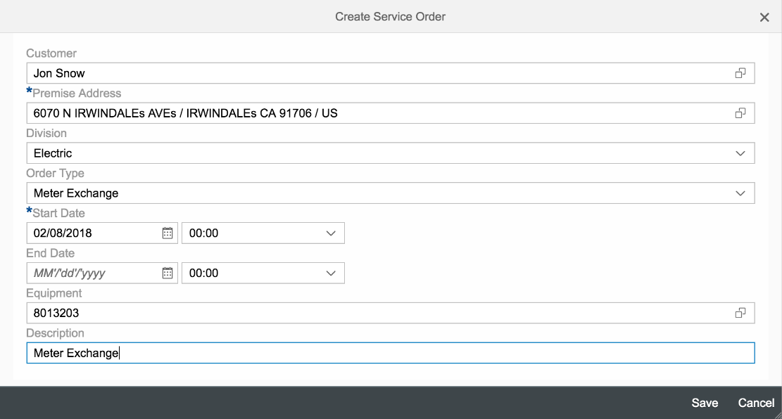
Figure 1 – Create a New Service Order

Once a new SO has been created, the order will be handled based on what is required in order to get the assigned tasks done. This will be covered in BPD DF-WM-02 - Handle Field Orders – Manage Field Orders.
Orders that are linked to a customer are viewable in Hybris C4C with creation dates, status (open vs. completed, etc.). The order status will be used to as a reference by the users to determine where the order is at in its lifecycle (ex. in field, onsite, etc.).
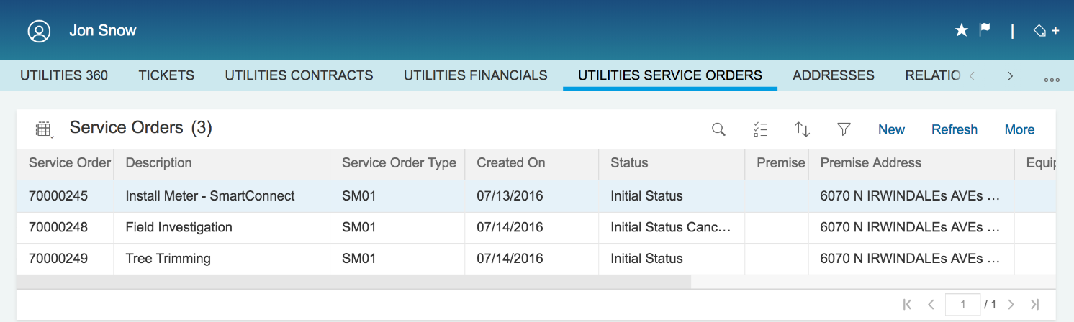
Figure 2 – Service Order List

The authorized users will also be able to perform the edit to existing order in Hybris C4C and the enhancement E-CIM-CS-05 Order Creation has been identified to provide necessary fields that are needed when changing existing SO.
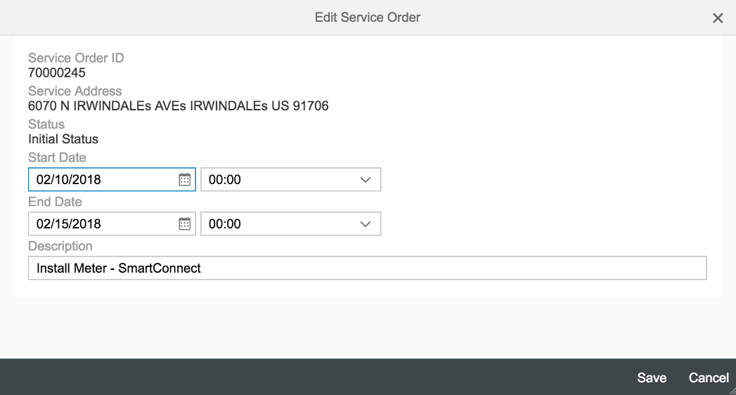
Figure 3 – Edit Service Order

2.1.2 Work Order Creation for SCE Customers
When a customer calls SCE for service, the user creates a new SO by selecting appropriate order type (refer to figure 1) that is relevant to customer’s request. A SN will be created in the background automatically. A unique number is assigned to the order by the system automatically. Confirming a BP and premise will be key criteria (by SAP Standard functionality) when creating a work request for the field personnel to carry out the task. The list of service orders can be shown in C4C showing the type of orders created with current status for the specific location. (Refer to Figure 2)

2.1.3 Work Order Creation for non-SCE Customers
There is a scenario in which either BP and/or premise cannot be found due to the fact that the caller is a person who does not have any business associated with SCE trying to inform about issue at certain location. Such caller can be categorized as non-SCE customers who reports a problem with a location that cannot be located in the system. The enhancement E-CIM-CS-05 Order Creation will be used to handle this scenario (see figure 4 for backoffice screenshot). Again, the order type selection will still be the main key component to be selected determining the type of order as starting point. The field order note can be utilized to record the additional problem reported by the caller (see figure 5 for backoffice screenshot)

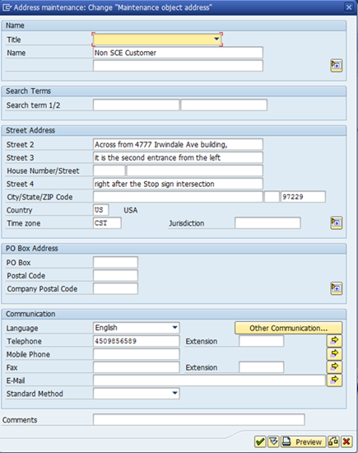
Figure 4 – Non-SCE customer and Non-Standard Address

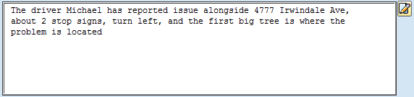
Figure 5 – Order note capturing additional information
The next step is to select a district by calling the enhancement E-DF-WM-02 - District Determination (see Figure 6 for backoffice screenshot) to determine the dispatched area where particular service is required to be carried out. In addition to this, the field PM Activity Type is also used to categorize the job code from the drop-down field. These two fields and work order routing are to be further detailed in the BPD DF-WM-02 - Handle Field Orders – Manage Field Orders.
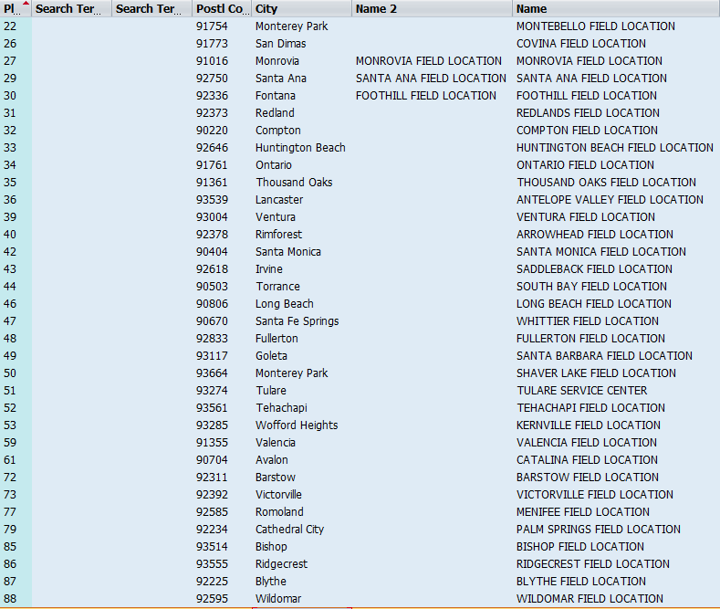
Figure 6 – Dispatched Areas

2.1.4 Work Order Completion
The C4C user will be able to view the status of the work order throughout the life cycle of the work order (BPD DF-WM-02 - Handle Field Orders – Manage Field Orders). The list of work order completion status will be addressed in D&F BPD.
If additional action is needed by a different department (e.g., CCC, RSO, etc.) to complete the service order and/or customer request, T&D will initiate a request to the required department. (BPD DF-WM-02 - Handle Field Orders – Manage Field Orders).

2.2 Process / Performance Improvement
- Improved reporting data capabilities.
- The work orders will be stored in S/4HANA and there are useful standard SAP reports that can be used for order lifecycle improvement, order tracking, and customer service satisfaction.
- Users can see work orders related to a customer in the system (ie. Work order type, status, etc).
- Work order history log to provide better information when there is a need to perform investigation.

2.3 Prerequisites and Inputs
- Business Partner
- Premise (if required)
- Order Type

2.4 General Assumptions
- Click will be served as scheduler to assign the skilled personnel and work duration based on order type after the order has been created
- There will be an interface between S4/Hana and Click to create the request in Click to be scheduled. (Refer to BPD DF-WM-02 - Handle Field Orders – Manage Field Orders)
- There will be an inbound interface from Click to S/4HANA to update and complete the service order with status and comments (Refer to BPD DF-WM-02 - Handle Field Orders – Manage Field Orders)

2.5 Business Process Hierarchy
This Business Process Hierarchy provides a listing of all scenarios/business processes, sub-processes, and SAP Transaction codes identified to support this process.
Level 1 | Level 2 | Level 3 | Level 4
Back Office  (CCC, GC Services/BCD/RSO) | Process Field Work Request | Display Service Order | IW33
Front Office  (CCC, GC Services/BCD) | Process Field Work Request | Create Service Order  Change Service Order  Display Service Order | Front Office/C4C  IW31  IW32  IW33
CCC, GC Services/BCD | View Field Work Order | Display Service Order | IW33

2.6 Process Flows
This BPD will cover 1 process, including Work Order Processing. Each subsection where the process is detailed will have a process flow diagram for that process and a table detailing the steps that are taken within that process including processes handled outside of SAP.

2.6.1 Work Order Processing

Process Flow Diagram

Process Flow Steps

Step | Description of Step | T-Code | Role(s) | If step is relevant for a Control, add Requirement  ID
10 | Start  Customer starts Work Order request at IVR/SCE.com. Proceed to Step 30. | N/A | IVR/SCE.com
20 | Start  Front Office Agent receives request from the customer. Proceed to Step 80 | N/A | Field Work Order Processing – CCC/BCD
25 | Start  Customer request via IVR receives request from the customer. Proceed to Step 70 | N/A | Field Work Order Processing – CCC/BCD
30 | Create Work Order | S/4HANA  IW31 | S/4HANA
40 | Successful?  Decision point – Was the Work Order created successfully? If yes, go to Step 50. If no, go to Step 60. | S/4HANA | S/4HANA
50 | Create Customer Contact  A Customer Contact is automatically created to log the successful creation of the Work Order for the customer. Once complete, go to Step 120. | S/4HANA  BCT0 | S/4HANA
60 | Create Case  If the creation of the Work Order fails, an automatic BPEM case is created. Once complete, go to Step 120. | S/4HANA  EMMAC1 | S/4HANA
70 | Call Routed to Agent | N/A | Field Work Order Processing – CCC/BCD
80 | Manage Business Partner | Hybris C4C  BP | Field Work Order Processing – CCC/BCD
90 | Premise Required?  Decision point – Is the creation premise required to create the Work Order? | Hybris C4C | Field Work Order Processing – CCC/BCD
100 | Create Work Order | Hybris C4C  IW31 | Field Work Order Processing – CCC/BCD
110 | Create Activity  An activity will be manually created to log the successful creation of the Work Order for the customer. Once complete, go to Step 120. | Hybris C4C | Field Work Order Processing – CCC/BCD
120 | Manage Field Orders  Orders will be fulfilled by DF-WM-02 . | S/4HANA | Field Work Order Processing
130 | End  The process ends. | N/A | N/A

2.7 3rd Party and SCE Legacy System Integrations
3rd Party or SCE Legacy System Integration | Description of Integration and Required Change to 3rd Party or SCE Legacy System | Estimated Complexity of 3rd Party or SCE Legacy system change
Click
OMS

2.8 Data Elements

2.8.1 Service Order Data Elements

Please refer to the BPD DF-WM-02 - Handle Field Orders - Manage Field Orders for detail data elements.

2.8.2 Source Systems and Data Volumes
Currently it is estimated around almost 50,000 created in the last 6 months.

2.9 Cloud for Customer (C4C) Integration

2.9.1 Processes
Work Orders will be viewable from C4C Front end system, Orders that are linked to a premise and/or customer are viewable with historical dates, status (open vs. completed, etc.). New Work Order can be created, changed or cancelled via C4C system.

2.9.2 C4C Views
Screen will be available in C4C system where agent can view Work orders. Also option will be available for front office agent to create, change and cancel work order.

2.9.3 Activity
A new activity can be created when a new work order created or changed in the system.

2.10 Exception Management Requirements
This section outlines a high level description of each BPEM Case or other user workflow items (such as “Tickets” used by Front Office) used to route work requests between business areas. The companion document for this section which outlines the detail of each case is documented in APSE on the Exception Case Template General Document #8.
User Exception Scenario / Description | User Group | Initiated by | Work Distribution
N/A

2.11 Process Risks and Mitigation
Risk Statement | Mitigation
N/A | N/A

2.12 Key Performance Indicators
The following have been identified as KPI’s at Southern California Edison, along with the means of measuring each KPI and the current measurement statistic for each KPI:
Measured KPI | Description | Measurement Method | Current Statistic
N/A

2.12.1 Key Metric Definition
The following have been identified as key metrics at Southern California Edison that require business rule for calculation:
Key Metric | Description | Business Rule | Reference
N/A | N/A | N/A | N/A

3 Controls, Regulatory Rules, and Security

Requirement  ID (from RTM) | “As-Is” Control Requirement | “To Be” Risk Statement | “To-Be” Control Activity” | Control Automation (manual, IT dependent- manual, automated | Relevant technical identifier or RICEFW reference
N/A | N/A | N/A | N/A | N/A | N/A

3.1 Security Considerations
Role | Transaction Code (T-Code) | T-Code Description | Functional Restriction | Organizational Restriction
Field Work Order Processing – All Users | C4C (Workcenter: Call Center) | Display Work Order | Display
Field Work Order Processing – CCC/BCD/RSO | IW31 | Create Work Order | Create
Field Work Order Processing – CCC/BCD/RSO | C4C (Workcenter: Call Center) | Create Work Order | Create
Field Work Order Processing – CCC/BCD/RSO | C4C (Workcenter: Call Center) | Change Work Order | Change/Cancel
Field Work Order Processing – CCC/BCD/RSO | C4C (Workcenter: Call Center) | Display Work Order | Display
Field Work Order Processing – CCC/BCD/RSO | IW31 | Create Work Order | Create
Field Work Order Processing – CCC/BCD/RSO | IW32 | Change Work Order | Change/Cancel
Field Work Order Processing – CCC/BCD/RSO | IW33 | Display Work Order | Display
Field Work Order Processing – Credit/Collections/Billing/CCC/BCD | IW33 | Display Work Order | Display

3.2 Custom Program/Transaction Codes

Custom Table | Authorization Grp Assigned | Custom T-code for the Table | Table Access (display/update) | RICEFW Reference ID
N/A | N/A | N/A | N/A | N/A

3.3 Custom Table/Transaction Codes

Custom Table | Authorization Grp Assigned | Custom T-code for the Table | Table Access (display/update) | RICEFW Reference ID
N/A | N/A | N/A | N/A | N/A

3.4 Data Criticality and Cybersecurity Baseline Risks
Specify Data Classification /Special Handling or Regulatory Requirement  What is the classification of Data? Does it trigger any special regulations?  Please select the classification / Sensitivity of the Data. This will help us Assess the Risk associated and remediation measures if any. | <Select all that apply>  ☐ PII - Personal Identifiable Information / Privacy Law  ☐ CEII - Critical Energy Infrastructure Information  ☐ FERC SOC (Standards of Conduct)  ☐ NERC CIP Confidential  ☐ Sarbanes-Oxley (SOX) financial reporting data  ☐ SCE utility data accessible by affiliate companies (CPUC)  ☐ PCI - Payment Card Industry Compliance  ☐ Customer Information Service Request (CISR, CISR-DRP)  ☐ Other _<Please Specify>_  ☒ Internal  ☐ Public  ☒ Confidential
Please identify which business Group/Role will require access to the data and/or solution:  Please select the list of Busines Groups will have access to this Data / Process. This will help us Determine the Impact and Risk Spread. Will ensure efficient Risk mitigation measures. | <Select all that apply>  ☐ SCE Customer, Res./Comm. Customer;  ☒ SCE OU, Business Function Organization Name: CS, T&D  ☒ Vendor: ELMS  ☐ External business partner(s) & SaaS providers  ☒ External on-shore contractors  ☒ External off-shore contractors  ☐ SCE Affiliate Company Employees  ☒ SCE Employees, specify if they have Marketing Function responsibilities (e.g., ES&M) CCC, BCD  ☒ SCE contract workers - ELMS  ☐ Regulatory Agencies  ☐ Others _<Please Specify>_
How many of the SCE Customer, Employee, Vendors will use or affected by the Business Process?  To identify the Impact if services are adversely affected. | 1000+
How much Information/data would be processed, received or tramitted by the Business Process?
The data volume that will be utilized by this process. Helps us in determining the Impact and criticality
Number of business transactions in average?  These are the number of transactions process by the application on average. The number of transactions help in understanding criticality and Impact. | Today’s Basic Work Request that are sent to field (does not include Trouble Orders)  2017 - to Field - 180,889  2016 - to Field - 168,718  2015 - to Field - 204,991  ELMS Work Orders- 683,889 for years 2004-2018, approx 48,849 per year set by field
Additional Security Consideration: | Any Cybersecurity impact in addition to SAP system security:  - Internet Facing Web Application? No  - Internet Facing Application Programming Interface? No  - 3rd party Fedrated Authentication & Authorization, Single Sign On? No

Technical Considerations

4.1 RICEF-W Assessment

Reports
Report Name & Description (List Requirements met by this Report) | Complexity | Reference ID
N/A | N/A | N/A

Interfaces
Interface Name & Description (List Requirements met by this Interface) | Complexity | Reference ID
N/A | N/A | N/A

Conversion
Conversion Name & Description (List Requirements met by this Conversion) | Complexity | Reference ID
N/A

Extension/Enhancements
Extension Name & Description (List Requirements met by this Extension) | Complexity | Reference ID
Ability for user (creator or other system users) to subscribe to receive status alert for specific request | M | E-CIM-CS-05  Work Order Notification
Work Order Creation with all required parameters. | M | E-CIM-CS-05  Order Creation
Ability for the user to issue a request using the following: BP master data, Technical Master data, Free Form Notes, Category / Action Required / Goal (for sales Task replacement) or Type and Sub-type | M | E-CIM-CS-05 Request Creation
The users shall be able to (global) search for transaction using multiple selection criteria which includes (removed) types and sub-types (Action Requested and Goal/Reason) and Based on parent work order, system will automatically create individual child work orders and route to appropriate group | M | E-CIM-CS-05 Request Search

Forms
Form Name & Description (List Requirements met by this Form) | Complexity | Reference ID
N/A | N/A | N/A

Workflows
Workflow Name & Description (List Requirements met by this Workflow) | Complexity | Reference ID
N/A | N/A | N/A

IDEX Considerations
N/A

Production System Cut-over Considerations
- Active or future work order will be converted into the SAP system
- Employees will be able to view historical work orders via CSSWS/CWO for a minimum of 12 months and be able to query for a report after the system is disabled.

4.4 Other Considerations
N/A

Change Management

5.1 Change Impacts
Change Element Short Description | Change Impact Category | Audience Group(s) | Impact | Business Effort
Business Customer Division (BCD) will have the opportunity to issue the work order directly to the field instead of an email or front office task (ex voltage, power quality, cross meter, etc.). Currently BCD will send a tasks or emails to COE. The capability will require more training for process but will reduce handoffs. | Benefit/Improvement; Process (457) | CS-CSOD-CCC All. CS-BCD-All | Low | Low
Front office will have the ability to schedule specific appointment times for customers for service orders as well as field inspections which provides the customer flexibility and increases customer satisfaction  Customer Impact: Provides customers flexibility and customer satisfaction | Benefit/Improvement;Decision Making (460) | CS-BCD-All;CS-CSOD-CCC All;Ext-Customers-All;T&D-All | Medium | Medium
The system will be able to issue an automated "add lock ring" request after a certain amount of days once a lock ring removal request has been completed which will minimize the amount of call backs to the contact center. Currently customers need to call back to request to add the lock ring once the electrical work has been completed or agents will need to tab on their calendars to add the lock ring back on the meter. | Benefit/Improvement; Process (461) | CS-CSOD-CCC All, CS-BCD-All | Low | Low
Field service orders do not have a separate access arrangements field. Comments field within order is currently limited to 40 characters. The user would need to go into the back office if longer text is required. Agents will need to use the comments field to be concise on the request and will need to focus the access arrangements at the premise level. Currently there is an access field in the field basic work requests that download into the field tools to be viewed (eg locked gates, dogs etc). Users will need to be trained to how to update the access arrangements. | Decision Making;Process (836) | CS-BCD-All;CS-CSOD-CCC All;CS-CSOD-Consumer Affairs | Medium | Medium
Front office users will have the ability to create a service order for a non-sce customer using the FOP launcher including non-standard addresses. Currently non-sce customers can call and request service orders which can be linked to the closest installed service. This is a change in process that will require users to access the back office UI. | Culture Shift;Process (837) | CS-BCD-All;CS-CSOD-CCC All;CS-CSOD-Consumer Affairs | Low | Low
Changes to technical master data will make changes to all appropriate levels automatically. Currently authorized users can manually change the Installed service and site levels but the service account is not updated. This causes the service address and the other levels to not match the premise level. | Benefit/Improvement;Process | CS-BCD-All;CS-CSOD-CCC All;CS-CSOD-Consumer Affairs;CS-CSOD-RSO All | Low | Low

Below is a description of each:
Change Element Short Description: Describes the ‘As-Is’ scenario and what is changing.
Change Impact Category: Determined by asking the questions below.
- Staffing Levels - Is the work effort increasing or decreasing (staffing levels), and how (e.g., task automation, new process/tasks)?
- Job Roles - Will the responsibilities, authority, or required skills for a job or job roles change? Will people be reporting to new leaders? Will managers’ responsibilities change?
- Compensation / Performance - Will the changes have such an impact on roles of an individual that merits a change in how they are compensated or how their performance will be evaluated? What behaviors are rewarded and recognized?
- Organization Structure - Is the ownership of the Process or Data changing (think departments, jobs, or roles, not individuals)?
- Decision Making - Will any of the changes impact how decisions are made, by or between, business units / departments? Who makes them, how they determine the criteria for making a change?
- Culture Shift - Will organizational value systems impact the way change happens or be impacted by the change? What are the underlying values of the organization that will directly influence the way change will be accepted and how much work will ultimately be required to ensure successful outcomes for the business?
- Location / Facilities - Will the change impact the physical location where they process is being implemented or require changes to the facilities to enable the process to be effective?
- Process - Any change to the current process (e.g. manual process becomes automatic, or vice versa)? Are there new processes being introduced or an old process being decommissioned? Is there a requirement to change an existing business rule or business policy? Will new business rule or policy needs to be introduced and enforced or complied to?
- Regulatory/ Legal - Are there any legal / regulatory requirements that might be impacted
- Technology - Are other applications impacted (e.g., going away, becoming read-only), or are there new requirements (e.g., new SW / HW, new version)
- Benefit/Improvement - Will there be an improvement or benefit to any of the stakeholders because of this change. (Be sure to include any pain points that are being alleviated)
- Other - Are there emotional implications stemming from any of these changes (think of buy-in issues or fears)
Audience Group(s): These are the affected departments, divisions etc…
Impact: The following were used to determine the impact:

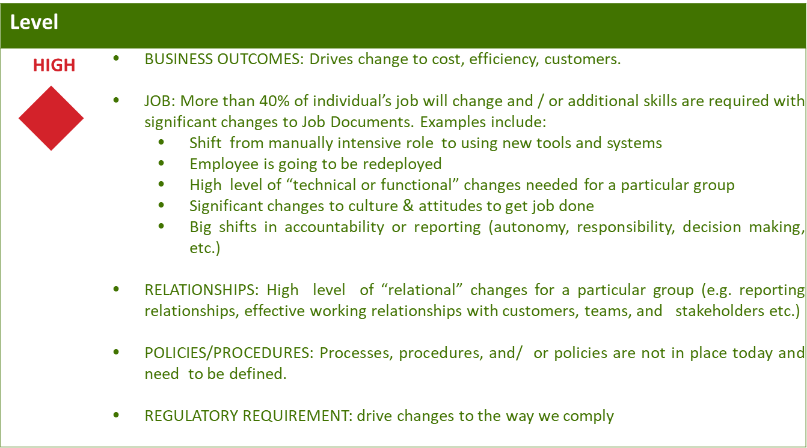
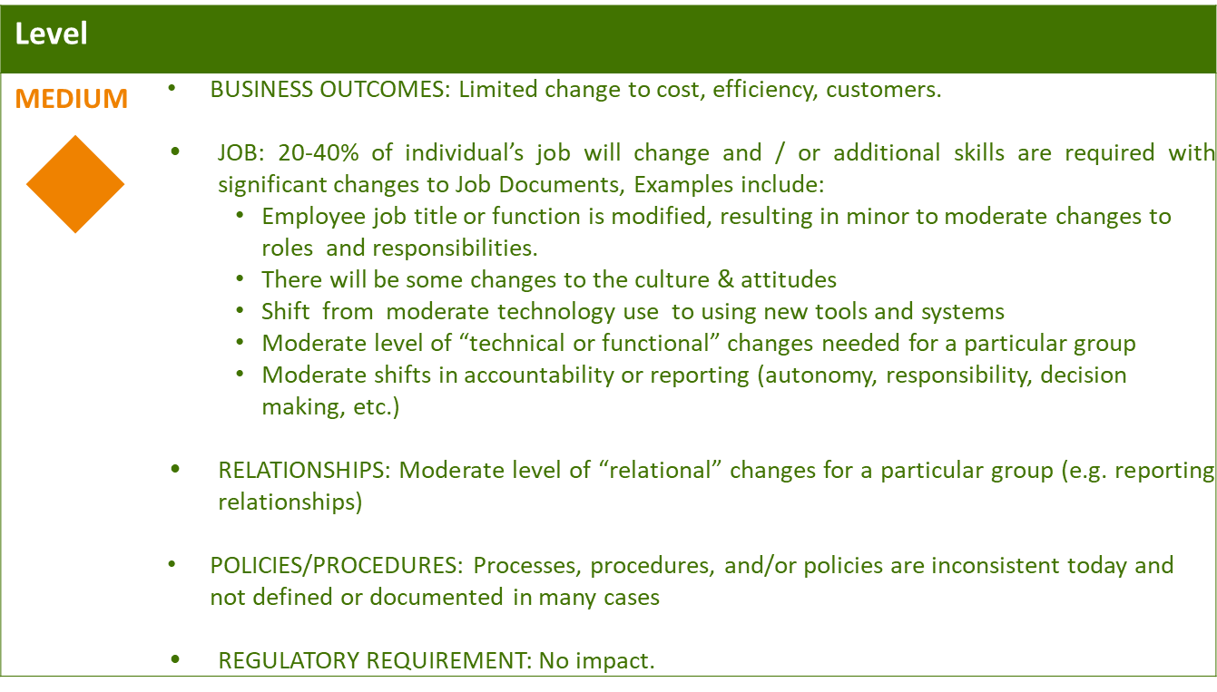
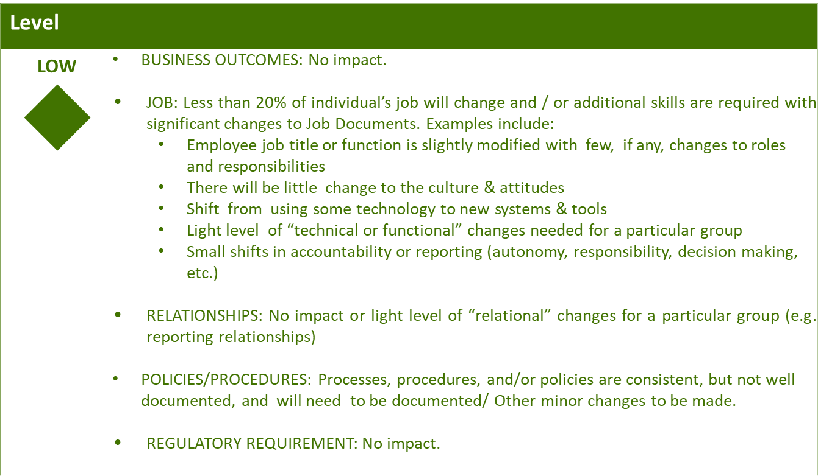

Business Effort: Initial assessment of the impact to the business High, Medium, Low

Requirements

